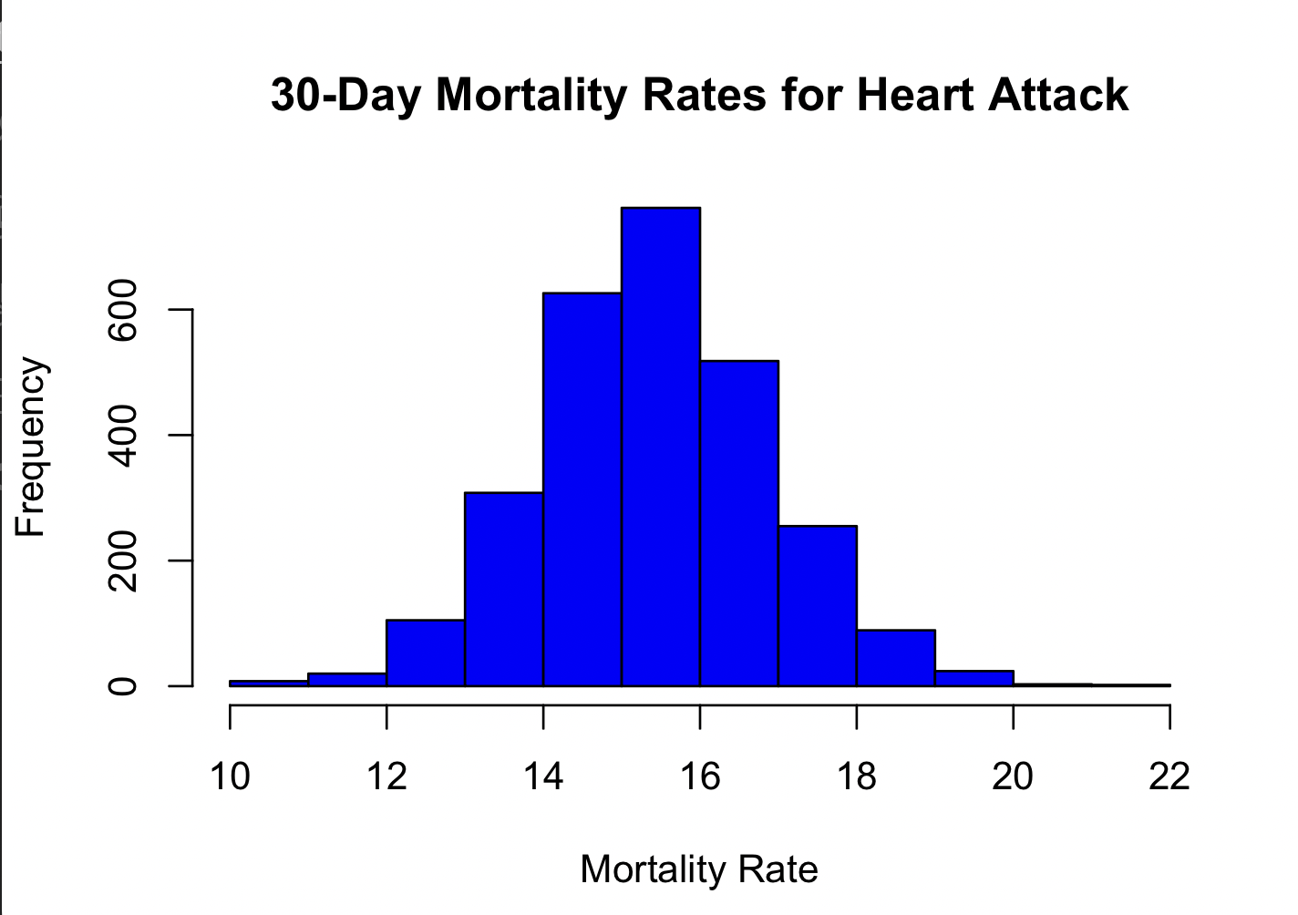

2. Finding the Best Hospital in a State
## Valid input : Check best hospital in Texas for heart attack
best("TX", "heart attack”)
# Expected output : " CYPRESS FAIRBANKS MEDICAL CENTER "
## Invalid state : Check error handling
best("ZZ", "heart attack”)
# Expected output : Error : " invalid state "
## Invalid outcome : Check error handling
best ("TX", " wrong outcome ")
# Expected output : Error : " invalid

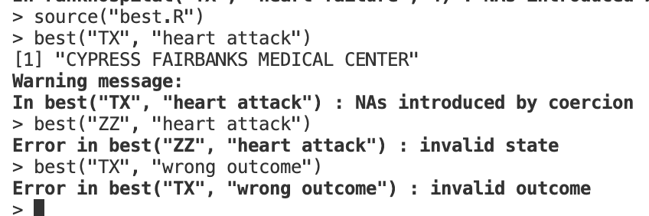outcome "

3. Ranking Hospitals by Outcome in a State

## Valid input : Rank 4th hospital in Texas for heart failure
rankhospital ("TX", " heart failure ", 4)
# Expected output : " DETAR HOSPITAL NAVARRO "
## Best hospital : Check " best " ranking
rankhospital ("TX", " heart failure ", " best ")
# Expected output : " FORT DUNCAN MEDICAL CENTER "
## Worst hospital : Check " worst " ranking
rankhospital ("TX", " heart failure ", " worst ")
# Expected output : " MISSION REGIONAL MEDICAL CENTER "
## Exceeding number of hospitals
rankhospital ("TX", " heart failure ", 10000)
# Expected output : NA

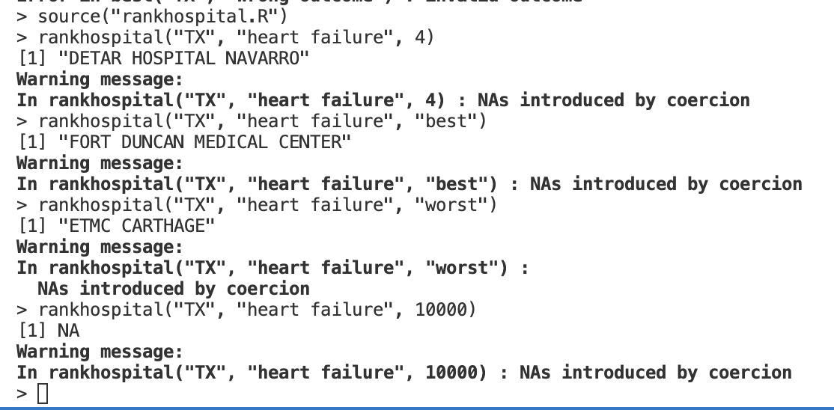

4. Ranking Hospitals Across All States

## Best hospitals for heart attack across all states
head ( rankall (" heart attack ", " best ") , 10)
# Expected output : Data frame with best hospitals for each state
## 20 th ranked hospital for heart attack across all states
head ( rankall (" heart attack ", 20) , 10)
# Expected output : Data frame with 20 th ranked hospitals for each state
## Missing data handling
tail ( rankall (" heart failure ", " worst ") , 5)
# Expected output : Data frame with " worst " hospitals ; NA for missing
States

